PORTUGAL

Portugal has a rich seafaring past, superb beach resorts, wistful towns and a landscape wreathed in olive groves, vineyards and wheat fields. Littered with UNESCO World Heritage sites and graced by one of Europe's most relaxed and attractive capitals, it also remains refreshingly affordable.
Savouring life slowly is a Portuguese passion, and much of the best is humble - traditional folk festivals; simple, honest food drowning in olive oil; music that pulls at the heart strings, recalling past love and glories; and markets overflowing with fish, fruit and flowers.
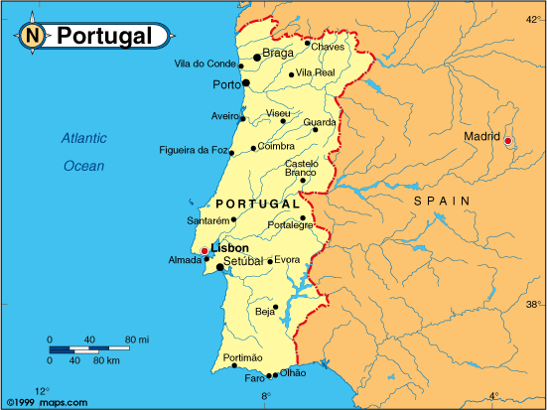

GEOGRAPHY
Portugal is situated at the south-west point of Europe and also includes the Madeira and Azores archipelagos in the Atlantic Ocean.
Mainland Portugal occupies an area of 88,889 km2. It is 218 km wide and 561 km long. It has 832 km of Atlantic coast and a 1,215 km border with Spain.

VISA The visa is to be obtained prior to arrival in the country

HOW TO GET THERE:
INTERNATIONAL AIRPORT: Portugal’s excellent geographical position makes it a stopover point for many foreign airlines at airports all over the country:
Lisbon - Portela Airport
Oporto - Dr. Francisco Sá Carneiro Airport
Faro - Faro Airport
Funchal, Madeira - Funchal Airport
Ponta Delgada, Azores - João Paulo II Airport

FLIGHTS INTO PORTUGAL
Air France, Swiss airways, Lufthansa, British airways

CURRENCY:
Portugal is one of 12 European Union countries whose common official currency is the euro.
1 euro is divided into 100 cents. The coins come in denominations of 1, 2, 5, 10, 20 and 50 cents, and 1 and 2 euros.
The notes are differentiated by their size and colour and come in denominations of 5, 10, 20, 50, 100, 200 and 500 euros.

1EURO = 66 INR (approximate cost of the day)

GETTING AROUND:
Portugal is a small country where you can get almost everywhere by train or bus, or of course by car. There should be no need to fly if you're not in a hurry.If you are, there are several daily flights from Lisbon to Porto and Faro, and less frequent flights by smaller aircrafts
The train is cheaper than the bus, and the lines are generally more scenic, but buses are usually faster.
The scenery is best appreciated by car. Car rental rates are among the lowest in Europe.

Car rentals: There are car rental services at airports, international rail terminuses and in the main towns and cities.
Drivers with mobility difficulties, or anyone who prefers to, can rent automatic or adapted vehicles.
To rent a car you must:
- be the minimum age of 21 to 25 years old, depending on the company’s rental policy
- show identification (identity card for EU citizens or a valid passport for other nationalities)
- have had a driving licence for more than one year

Taxi: Traveling by taxi is relatively cheap, and in all cities plentiful. Across major towns and for shorter journeys in areas where other transportation may be limited, a taxi is worth considering. Outside major towns, you can also negotiate spesific fares and hire a taxi for a few hours.
Bus: Bus services links most of the country's smaller towns and villages as well as shadow many of the main train routes.
Keep in mind that some timetables often are designed for children who travel to and from school. Departures can be very early in the morning.
Most bus services were earlier operated by the state-owned RN (Rodoviária Nacional). This has now been privatized, and there are a number of private companies. RN Expressos covers long-distance routes. Check with the Tourist Office for the most convenient bus.
For long-distance journeys pick up timetables and make reservations at the local bus station. For local buses you purchase your ticket on board.

Trains: All trains are operated by CP (Caminhos de Ferro Portugueses).
Categories:
Regional: Stop at most stations.
Inter-regional: Faster, stop only at major stations.
Intercidades: Twice as fast, twice as expensive. Reserve your seat in advance.
Rápidos: The fastest, most luxurious and expensive service.
Between Lisbon - Coimbra - Porto.
Ask in major stations for a copy of CP's official timetable (Guia Horário Oficial) if you plan to do a lot of traveling by train. It covers routes and schedules throughout the country. Timetables are also usually posted on station walls.
Tickets must be purchased at the station in advance. Rail cards for tourists (Bilhetes Turisticos) will save you some money. They are valid for 7, 14 or 21 days. Other discount tickets are also available.

Air: There are several Portuguese airlines offering regular domestic and international flights.
TAP (www.tap.pt) - Air Portugal is the country’s "flagship" airline and has scheduled flights to more than 50 international destinations and domestic flights between Lisbon, Oporto, Faro, Madeira and the Azores, and also between Madeira and Porto Santo.
SATA (www.sata.pt) has regular flights between all the islands of the Azores and from the Azores to Madeira and mainland Portugal. SATA also offers regular flights to a number of international destinations.
ATA (www.aerocondor.com) - Aerocondor Transportes Aéreos operates regular domestic flights and international charters.

BUSINESS HOURS
Banks are open from 8.30 a.m. to 3 p.m. five working days a week.
Normal business hours for shops are from 9 am to 1 pm and from 3 pm to 7 pm from Monday to Friday.
Shops close at 1 p.m. on Saturdays from January to November, but are open from 9 am to 1 pm and from 3 pm to 7 pm from Monday to Saturday in December.

CLIMATE:
Mainland Portugal
The climate in Portugal varies considerably from one region to another and is influenced by the relief, latitude and proximity to the sea, which offers mild winters, especially in the Algarve.
In the Porto e Norte area and the Centro de Portugal region, particularly inland, nearer Spain, the winters are colder, although the temperatures are still mild when compared to the rest of Europe. There is some snowfall. It occurs most in the Serra da Estrela Mountains, where we find the highest point in mainland Portugal (1,991 m) and where it is sometimes possible to ski.
The summers are hot and dry, especially in the inland areas (Trás-os-Montes in north-eastern Portugal and Alentejo). Temperatures are slightly lower in the coastal areas, because of the influence of the sea.
There are often warm, sunny days in autumn. Nice weather at the beginning of November is often called "St. Martin’s summer" as this saint’s day is on 11 November.
Azores
The climate in the Azores is influenced by the islands’ latitude and by the Gulf Stream, and temperatures are mild there all year round. The same factors also influence the sea temperature, which is very pleasant both in winter and summer and ideal for nautical sports all year round.
Madeira
The subtropical characteristics of the weather in the Madeira Archipelago can be explained by its geographical position and mountainous relief. The climate in Madeira is exceptionally mild, with average temperatures varying between 24 ºC in summer and 19 ºC in winter.
The sea temperature is also very pleasant all year round, thanks to the influence of the warm Gulf Stream. It varies between 18 ºC in winter and 22 ºC in summer.
Table of temperatures
(average temperatures - 1961/90 - in ºC and ªF)
Place |  | Jan./March |  | April/June |  | July/Sept. |  | Oct./Dec.
 |  | Air | Sea | Air | Sea | Air | Sea | Air | Sea
Porto | ºC | 10,3 | 12,9 * | 15,4 | 14,4 * | 19,6 | 15,9 * | 12,8 | 15,0 *
(Porto e Norte) | ºF | 50,5 | 55,2 * | 59,7 | 57,9 * | 67,3 | 60.6 * | 55,0 | 59,0 *
Coimbra | ºC | 11,2 | 13,3 ** | 16,7 | 15,0 ** | 21,5 | 16,8 ** | 13,6 | 15,3 **
(Centro de  Portugal) | ºF | 52,1 | 55,9 ** | 62,0 | 59,0 ** | 70,7 | 62,2 ** | 56,5 | 59,5 **
Guarda | ºC | 5,0 | - | 11,7 | - | 18,2 | - | 7,7 | -
(Centro de  Portugal) | ºF | 41,0 | - | 53,1 | - | 64,8 | - | 45,9 | -
Monte Estoril | ºC | 17,1 | 14,9 | 21,8 | 17,5 | 26,3 | 19,5 | 17,2 | 16,1
(Lisboa) | ºF | 62,8 | 58,8 | 71,2 | 63,5 | 79,3 | 67,1 | 53,0 | 60,0
Évora | ºC | 10,5 | 14,3 *** | 16,6 | 15,1 *** | 28,4 | 16,9 *** | 13,3 | 16,0 ***
(Alentejo) | ºF | 50,9 | 57,7 *** | 61,9 | 59,2 *** | 83,1 | 62,4 *** | 55,9 | 60,8 ***
Vilamoura | ºC | 17,0 | 15,9 | 22,4 | 19,4 | 27,3 | 22,6 | 17,7 | 17,0
(Algarve) | ºF | 62,6 | 60,6 | 72,3 | 66,9 | 81,1 | 72,7 | 63,9 | 62,6
Santa Maria | ºC | 17,0 | 17,2 | 19,7 | 18,8 | 23,9 | 22,2 | 19,4 | 20,5
(Azores) | ºF | 62,6 | 63,0 | 65,8 | 65,8 | 75,0 | 72,0 | 66,9 | 68,9
Funchal | ºC | 19,4 | 18,7 | 21,8 | 20,0 | 24,9 | 22,7 | 21,3 | 21,4
(Madeira) | ºF | 66,9 | 65,7 | 71,2 | 68,0 | 76,8 | 72,9 | 70,3 | 70,5

* Viana do Castelo

** São Pedro de Muel

*** Sines

CLOTHING:
The months of July and August can be very warm in Portugal, so it is advisable to wear light clothing. In spring and autumn - the temperate climate seasons - light clothing is recommended, accompanied by some warmer clothes for days when the temperature may fall

TIME:
Portugal Is 4 hours 30 mins behind us

ELECTRICITY:
The electric current in Portugal is 230/400 volts at a frequency of 50 hertz and sockets comply with European standards.

DIALING CODE:
The international dialing code is +351.

TIPPING:
Service is included in the bill in restaurants, though it is customary to leave an additional tip of about 5-10% of the total.
It is also normal to tip taxi drivers 5-10 % or rounding up the amount paid to the nearest euro.

LANGUAGE:
One of the Latin languages, Portuguese is the third most spoken European language in the world and the native tongue of about 200 million people.
The Portuguese-speaking countries are scattered all over the world. Portuguese is spoken in Africa (Angola, Cape Verde, Guinea-Bissau, Mozambique and São Tomé e Príncipe), in South America (Brazil) and in Asia, (East Timor, the youngest nation in the world).
In Portugal there are lots of people who are able to communicate in English, French and Spanish.

SAFETY:
Portugal is generally a safe country. This does not mean that you should throw caution to the wind and let down your guard, but generally speaking, you are safer in Portugal than in most other western countries. In particular, there is a refreshing lack of boozy stupidity at the weekends, despite the profusion of bars open to all hours in the major cities. Also, there are no internal conflicts to speak of, and no terrorism-related danger.
Like any big city, there are some areas of Lisbon and Porto that you might want to avoid, especially at night. Also like in any other tourist areas, you might want to have in mind that pickpockets do tend to target tourists more frequently - but some common sense should be enough to keep you safe.Wear a money belt;most places accept major credit cards

FOOD
This is potentially the most varied experience to have in the country.
Portuguese cuisine evolved from hearty peasant food drawn from the seafood of the country's abundant coast and the pork raised on the limited grazing land of its interior. From these humble origins, Mediterranean ingredients and spices brought back to the country during its exploration and colonisation of the East Indies and the Far East helped shape what is regarded as 'typical' Portuguese cuisine.
Soup is the essential first course of any Portuguese meal. The most popular is the Minho specialty, caldo verde, made from kale, potatoes and spiced sausage.
You will see another Portuguese staple bacalhau (dried codfish) everywhere. Locals will tell you that there are as many ways to cook this revered dish as there are days in the year, or even more.
The most common of Portugal's delicious fish (peixe) dishes revolve around sole (linguado) and sardines (sardinha) although salmon (salmão) and trout (truta) are also featured heavily. These are fried, grilled or served in a variety of sauces.
You'll see grills, thick with the smoke of charring meat, in front of many restaurants during your stay. Other than traditional sardines and salmon, Portuguese grilled chicken -- marinated in chilli, garlic and olive oil -- is world famous.
Vegetarians may have a tough time of it in Portugal, at least in traditional Portuguese restaurants. In most restaurants, vegetables (usually boiled or fried potatoes) are simply a garnish to the main meat dish. Even 'vegetarian' salads and dishes may just substitute tuna (which locals don't seem to regard as a 'meat') for ham or sausage. However, the Portuguese really like their choose-5-items salad bars, and restaurants serving Indian, Chinese, Mexican, or Italian fare can be found in most cities.
In many Portuguese restaurants, if you order a salad it will come sprinkled with salt - if you are watching your salt intake, or just don't like this idea, you can ask for it "sem sal" (without salt).
A few restaurants, particularly in non-tourist areas, do not have a menu, you have to go in and ask, and they will list a few items for you to choose from. It is wise to get the price written down when you do this so as to avoid any nasty surprises when the bill comes. However, in this type of restaurants, the price for each one of the options is very similar, varying around from 5 to 10 euro per person.
Most restaurants bring you a selection of snacks at the start of your meal - bread, butter, cheese, olives and other small bites - invariably there is a cover charge on these items, around 5 euro. Do not be afraid to ask how much the cover charge is, and get them to take the items away if it is too much or if you are not planning to eat as much. It can be quite reasonable, but occasionally you will get ripped off.
If you have kitchen facilities, Portuguese grocery stores are surprisingly well-stocked with items such as lentils, veggie burgers, couscous, and inexpensive fruits, vegetables, and cheeses.If you like hard cheese,try "queijo da serra",if you prefer soft cheese,try regueijao. On larger shops mostly found in the principal cities, you can also find many unusual items such as exotic fruits or drinks.
SHOPPING
The temptation of shopping is an irresistible temptation for most visitors to Portugal.
Best buys include locally-made leather goods, jewellery, fine porcelain and high-quality clothes ranging from thick hand-knitted sweaters to the latest fashion garments.
Thankfully, traditional arts and crafts have not been lost as a result of Portugal's rapid modernisation since the 1974 revolution. Pottery, ceramics and tiles are produced to high standards all over the country, with styles differing from region to region and town to town. Lace and embroidery are particularly good from Madeira.
Lisbon’s most popular shopping area is the Baixa, a compact downtown district comprising several parallel streets including the traffic-free Rua Augusta. A short walk up Rua do Carmo brings you to the fashionable Chiado district, which has almost totally recovered from a devastating fire in 1988. The Colombo Centre just off the city center at Benfica is the largest shopping mall in the Iberian Peninsula.
Visitors to Oporto should head for Rua de Santa Catarina in the main downtown area of the city. There are several upmarket boutiques and and fashion stores along Avenida da Boavista around the Meridien Park Atlantic Hotel.
CITIES

PORTO
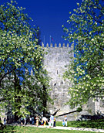

It was in Porto and the north that Portugal came into being as a country, which is why the region has such a rich and fascinating heritage.
This is a mountainous area with rivers, natural parks and steep, sloping hillsides covered with leafy vegetation. The granite from its mountains was used to build many of the region’s religious and historical monuments, such as the unpretentious Romanesque chapels and baroque churches.
History surrounds you when you visit the region’s castles - the castle at Guimarães was the birthplace of the nation’s founder and first king, Dom Afonso Henriques. And at the countless manor houses and palaces emblazoned with coats of arms, visitors are received with an aristocratic display of hospitality.
However, this region also owes much of its character to the great waterway that cuts it in half, the scenic River Douro, whose vine-filled valley is today classified as a world heritage site.
The river was given the name of ouro (gold) because it brings the water that the sun-drenched vines rely on to produce the world-famous Port wine. But also because this was the place from which ships used to set sail in the great period of Portuguese discovery. Or perhaps the name is due to the carved and gilded woodwork of the city’s countless baroque churches.
The fact remains that this ancient city gave its name to both Port wine and to the nation of Portugal. Much of its heritage is based on shipping and trade, making it a bustling and passionate city. Porto is also classified as world heritage site. Perhaps these are the reasons why Porto finds its way into the hearts of its visitors.
Sights in and around Porto

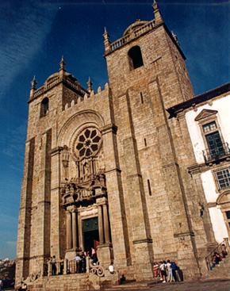
Cathedral
Built in the 12th century, in the Roman style, it was later modified for several times and the original architecture was altered. Inside, it is worth admiring the paintings by Nicolau Nasoni, the silver altarpiece of the Holy Sacrament, the João Gordo ("Fat John") Chapel and the cloister. At the southern tower, there are still two standard measures engraved in the stone, the last vestiges of the Medieval fair which took place in the large Cathedral’s grounds.

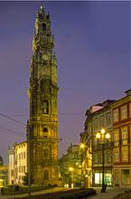
Clergymen Church and Tower
A monument of the Baroque style, built between 1754 and 1763 by the Italian architect Nicolau Nasoni, Torre dos Clérigos became the emblem of Oporto. From the top of the Tower, six floors and 76 metres high, after climbing an endless spiral staircase with 225 stairs, the visitor enjoys dazzling views over the city, the river Douro and its estuary.

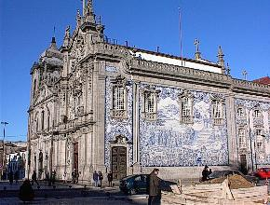
Carmo Church
Situated close to the Clergymen Tower and Church (Igreja e Torre dos Clérigos), the Igreja do Carmo é remarkable construction, presenting an amazing panel of tiles on an exterior wall, representing scenes describing the foundation of the Carmelite Order.

Cedofeita Church
It is a peculiar church in the Portuguese Romanesque architecture, since it is the only building with one single nave covered by a stone vault, which explains the presence of massive exterior buttresses on the lateral walls. Spatially, it comprises a nave and a quadrangular top separated by a crossing that stands on calcareous capitals

Lapa Church
The Pope Benedito XIV set the Brotherhood of the Nossa Senhora da Lapa in 1755. The following year the current church was founded, its first stone having been laid on 17 July. This new building would replace a chapel and house the devoted ones that went there seeking shelter.

Santo Ildefonso Church
The church was constructed from 1709 on since the first church was in ruins. It was concluded in 18 July 1739. The nave is of polygonal type in proto-baroque style. Above the entablature there is a niche with the patron saint. It has steeple towers with dentils on the cornices, topped on each side by fantasy spheres and frontons. The walls are decorated with tiles by Jorge Colaço (1932), depicting scenes from the life of St. Ildefonso and allegories from the Eucharist

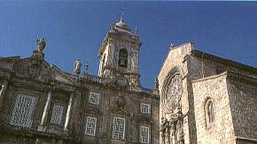

S. Francisco Church
The São Francisco Church is one of the few remaining medieval buildings in Porto. Also, it is the only Gothic church in the city. It was part of a Franciscan convent and its construction lasted from the late 14th century until the early 15th century. The medieval architectonic programme went through several occasional changes but its structure remained unaltered. Diogo de Castilho, following the instructions of João Carneiro, built the Carneiros Chapel, or the Chapel of the Baptism of Christ, in the 16th century. The new main

portal was built in the following century and had baroque characteristics. In the 17th and 18th centuries the interior of the church was completely covered with wood carvings, forming a sort of golden box. It is one of the most beautiful baroque interiors in the country. Although the wood carvings do not present a stylistic coherence, their great quality, which was the fruit of the best workshops in Porto, makes up a selection that enables the observation of its evolution. It is a true museum of gilt wood carving in the city.

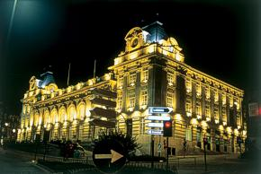
S. Bento Station Built on the site of an ancient convent, it was completed in 1916. Now, only regional trains pass through here. Inside, the immense panels of tiles creted by Jorge Colaço, reproducing historical scenes, add a rare artistic beauty to the station.
Stock Exchange Palace Baroque 18th century construction by Nicolau Nasoni. Worthy of notice are the church's interior decorated with Baroque-rococo gilt carvings, the polychromatic retable by Manuel Porto and the impressive 75.60-metres tower.
S. Bento Station

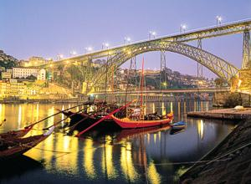
Ponte D. Luís I (D. Luís I Bridge) In accordance with the Law of 11/02/1879, the government determined the opening of the competition for the "construction of a metal bridge over the Douro River, in the place considered the most convenient in front of the city of Porto, for the replacement of the current suspended bridge". The winning proposal was the project of engineer Teófilo Seyrig, from the Belgian company Societé de Willebroeck. Teófilo Seyrig had already been the author of the plan and head of the team in the project of the Ponte D. Maria Pia (D. Maria Pia Bridge) as Eiffel's associate. This time he was the sole responsible for this work of the new and grand Ponte D. Luís I (D. Luís I Bridge). The construction works began in 1881 and the inauguration occurred on 31 October 1886). The arch comprises 172m of cord and is 44.6m tall. Ponte D. Luís

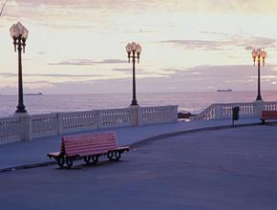
Ribeira The genuine city is visible at the quarter of Ribeira ("River-bank"), right by the river. Narrow and winding streets, dark arcades, typical houses with colourful façades set in a place which preserves the charm of sites marked by history, full of contrasts and curious characteristics. At night, the Ribeir acquires liveliness and animation, being one of the most sought after spaces, due to the numerous and pleasant restaurants, esplanades and nightclubs.

Museums

The Port Wine Museum Located in an 18th century warehouse where the wines of Companhia Geral da Agricultura das Vinhas do Alto Douro were once stored. This Museum aims to be an information centre about the Port wine, motivating visitors to discover the commercial history of the city relating it to this worldwide
Casa do Infante (House of the Prince) or Casa da Alfândega Velha (Old Custom House). Since then the services of the Municipal Archive are located there. The Archive promoted
a project of study and of deep remodelling of the building. An important Roman palace as well as better knowledge of ancient royal buildings from the 14th century to present days were the
result of the research carried out. The relevance of the archaeological finds led to the creation
of a site museum situated by the Archive and a small Tourist Office. The architectural project to remodel and update the Archive was designed by the architect Nuno Tasso de Sousa.
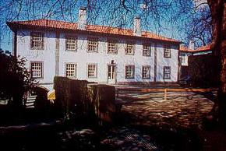
Romantic Museum of Quinta da Macieirinha The Museum reproduces the interior of a rich dwelling of the 19th century. Some aspects of the decorative arts of that period are worthy of notice.
Charles Albert, King of Piedmont and Sardinia, spent his last days in exile here, where he died on 28 July 1843. In his memory, some of the rooms he inhabited were restored.

Romantic Museum

Soares dos Reis National Museum The Museu Nacional Soares dos Reis, former Museu Portuense and first art museum in Portugal, was born in 1833, when D. Pedro IV of Portugal decided to establish in

the city of Porto a Museu de Pinturas e Estampas (Paintings and Prints Museum). The aim of the foundation of this Museum was the preservation of the artistic heritage that came mainly from extinct convents, and the simultaneous promotion of its use for cultural and pedagogical purposes. The Museum has been settled since 1940 in the Palacio dos Carrancas, currently considered a public interest property, and it was built in the late 18th century, by a wealthy family of Porto.
Misericordia museum The treasure of the Museum includes the Benefactor's Gallery and the "Fons Vitae" - a Flemish painting from the Brussels workshop (1520).

Vila Nova de Gaia
Seat of a county of commercial and industrial importance and facing Oporto across the river Douro, Vila Nova de Gaia is the main centre of Port wine production. Thus, the heart of the city is dominated by the Port lodges with their characteristic red roofs

emblazoned with well-known names, and over fifty companies based in narrow and twisting streets are engaged in blending and ageing the famous drink. Some of them offer guided tours so that visitors may see how Port is made and taste different samples.

Lisbon

Spreading out along the right bank of the Tagus, its downtown, the Baixa, is located in the 18th-century area around Rossio. East of the arcade Praça do Comércio, are the medieval quarters of Alfama and Mouraria, crowned by the magnificent St. George's Castle. To the west lie Bairro Alto and Madragoa, with their typical streets, and on the western extreme is Belém, with its Belém Tower, (the sentinel over the Tagus river that protects the entrance into Lisbon), the Jerónimos Monastery (masterpieces of Manueline architecture and classified in UNESCO's International Heritage list) and the Cultural Center of Belém.

Museums: Ancient Art, Chiado (Contemporary Art), Tile, Archaeology, Ethnology, Coach, Costume, Theater, Maritime, Military, City, Gulbenkian, Modern Art Center, and the Ricardo Espirito Santo Silva Foundation. Palaces open to the public: Ajuda and Fronteira. Churches: Cathedral (with Treasury); São Vicente de Fora; Conceição Velha (Manueline), São Roque and Sacred Art; Madre Deus; Santa Engrácia Pantheon (Baroque), and the Estrela Basilica.
Shopping: Downtown; Avenida de Roma, Praça de Londres, Avenida Guerra Junqueiro, and Amoreiras.
Nightlife: Bairro Alto and Avenida 24 de Julho.

Important sightseeing in Lisbon
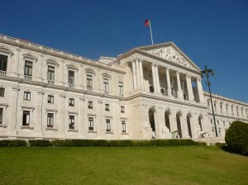
The Royal Palace is something you need to see. It is also known as the Palácio Nacional da Ajuda and it was built to replace the original palace that was destroyed in the earthquake of 1795. Another place that deserves your attention is The Basilica in Mafra. It is Portugal’s biggest religious monuments and one of the most awesome pieces of architecture in the world. Mafra’s Palace and Convent took over twenty-seven years to be built. So spend some time touring the inside and outside of this site.

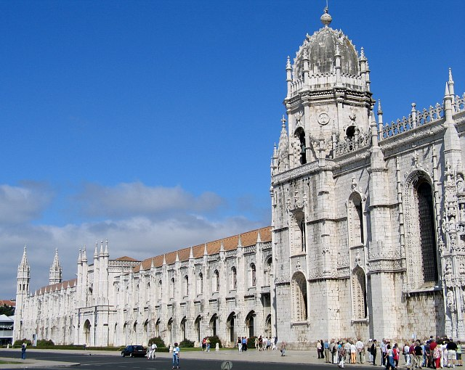
The Mosteiro dos Jeronimos’ construction began in 1502 and was completed before the end of the century and it is Lisbon’s most important landmark. You may hear it mentioned a lot while you are in the area. The Museu da Marinha (Maritime Museum) is one of the most important museums in all of Europe. It features over 17,000 items of the sea and 1,500 ship drawings and plans for you to look over. There is a lot of knowledge that can be learned when visiting this attraction.
Tue. - Sun.: 10.00 - 17.00
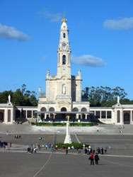
Fatima Sanctuary
Lisbon, Portugal
At the Fatima Sanctuary you will see the chapel that was built where the three Shepard (Jacinta, Lucia and Francisco) saw the apparition of Our Lady in 1917. You will also see the toms of Jacinta and Francisco and there are open air masses. You will wish to spend some time in this awesome part of the land.

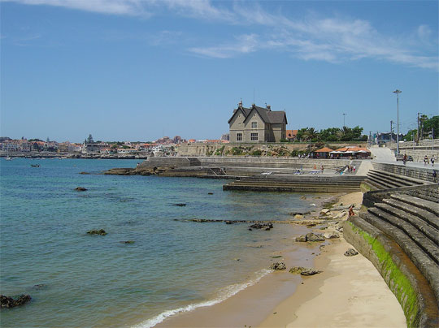
Portugal's Estorial Coast
Lisbon, Portugal
The Portugal’s Estorial Coast is one of the most beautiful and unspoiled coastlines in all of Europe. If you love the beaches you will want to spend some time on this coast. Take the day and just see all the area has to offer. You will be glad that you did.

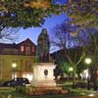
Basilica in Mafra
The Basilica in Mafra is Portugal’s biggest religious monuments and one of the most awesome pieces of architecture in the world. Mafra’s Palace and Convent took over twenty-seven years to be built. You will marvel at the interior as well as the exterior of this magnificent piece of work.

Museu da Marinha (Maritime Museum)
The Museu da Marinha (Maritime Museum) is one of the most important museums in all of Europe. It features over 17,000 items of the sea and 1,500 ship drawings and plans for you to look over. It is a fascinating and interesting museum and you will spend hours in it.
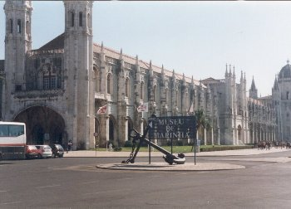

The Botanical Gardens Jardim Botanico (Estufa Fria)
Parque Eduardo
Lisbon, Portugal
The Botanical Gardens Jardim Botanico (Estufa Fria) will be a sight for you to see. There are so many beautiful plants and flowers from the tropics in the gardens. There is also a ‘hothouse’ or Estufa Quente which has plants from the dessert in it. Take some time to see this gorgeous botanical garden.

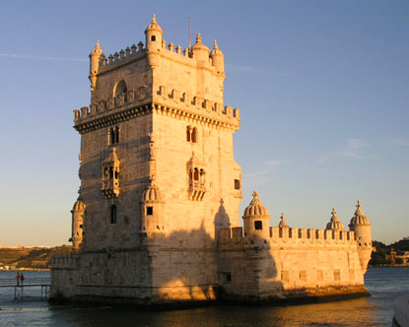
The Belem Tower (Torre de Belem)
Av. de Brasilia | Belem district
The Belem Tower (Torre de Belem) is located on the Tagus River and was built in the year 1521. It looks just like a miniature castle. You will love to look around at some of the building, which dates back to the 1500’s. The tower used to sit further out in the river but now is close to the waters edge.

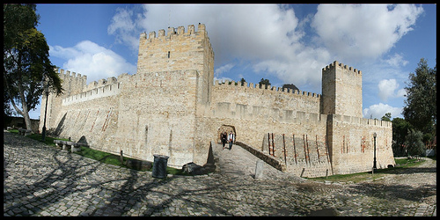
St. George's Castle (Castelo de Sao Jorge)
Rua da Costa do Castelo
St. George's Castle (Castelo de Sao Jorge) is on the highest hill in Lisbon. It is a very large and beautiful castle. You will just love the chance to take a look around this wonderful piece of architecture and the grounds that surround it. It is quite a fascinating sight to see.
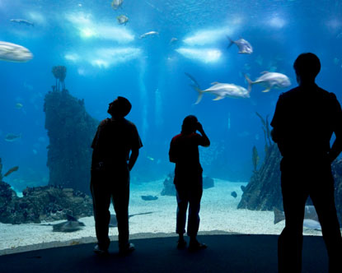
Oceanarium (Oceanario de Lisboa)
Parque das Nacoas
The Oceanarium (Oceanario de Lisboa) was the World Expo main attraction in Portugal. There are plenty of interactive displays in this neat building designed to help people learn about the oceans and aquatic life all around the world. There are also live displays and many exhibits for an afternoon of fun and learning.

Day trips from Lisbon

Sintra - Enchanting atmosphere; romantic palaces; Europe's westernmost point.
Queluz - Palace mixing Versailles' French grandeur and Portuguese eclecticism
Cascais - Playground of nobility; picturesque resort; a surfer's paradise
Estoril - The inspiration for James Bond; Europe's largest casino; spectacular golf courses
Ericeira - Traditional seaside village; surfing Mecca, superb seafood
Mafra - One of Europe's biggest palaces, the building that bankrupted the nation
Setúbal - Busy port; the birthplace of Manueline; dolphin watching
Sesimbra - Calm waters in a fishing town; a mystical cape.
Arrábida - Mediterranean vegetation by the Atlantic
Evora - A museum-town; a Roman temple; prehistoric sites
Obidos - "The wedding present town"; Portugal's prettiest medieval village
Alcobaça - World Heritage Monument: Europe's greatest Cistercian temple
Batalha - World Heritage Monument: European Gothic masterpiece; spectacular underground caves
Fátima - One of the Catholic world's most famous shrines

CENTRO DO PORTUGAL (CENTRAL PORTUGAL)

In the Centro de Portugal you will find a huge variety of nature, history and culture. First there are glacial lakes, spring waters and all kinds of outdoor sports: on land, in the sky or on water.
The Serra da Estrela Natural Park is worth a visit because it boasts clear spring waters at the sources of the rivers Zêzere and Mondego.
If you’re feeling energetic, go to Linhares where you can have a go at paragliding. For natural swimming pools try the Serra da Lousã and the Serra do Açor. And for peaceful footpaths visit the Serra do Caramulo. All of this is in the Centro de Portugal, where you will also find opportunities for canoeing and rafting, rock-climbing, abseiling and many other adventure sports. And be sure to spend some time on the Atlantic coastline with its white sand and high waves.
Also in the Centro de Portugal is Coimbra, where Portugal’s oldest university is to be found, with its fabulous baroque library.
The region is filled with the history of fierce battles and stories of Portugal’s roots before it became a nation. Get to know the historic villages such as Monsanto. Get to know the cities too, such as Guarda or Viseu, dominated by the traditional stone architecture of Centro de Portugal.
The Centro de Portugal is a region of warm hospitality, offering visitors genuine village tourism. The charm of the people is to be seen in the authenticity of their rituals, and their popular religious festivities, such as Easter. But it is also found in their cuisine, with its cheeses, sausages and mountain honey. All of this is waiting for you.

ALENTEJO

Inland, the vast golden wheat fields undulate in the wind; along the coast, unspoilt beaches look rugged and unexplored.
The open, ample landscape is peppered with cork-oaks or olive trees that have withstood the ravages of time. Occasionally sturdy fortress walls rise up from hills, as at Marvão or Monsaraz, or you’ll see just a simple dolmen reminding you of the magic of the place. Atop small hills stand white one-storey farmsteads, while the castles are reminders of the battles and conquests that once took place here. The patios and gardens bear witness to the influence of the Arabs, who helped to shape the people and the nature.
In the Alentejo, the brute force of the land dictates the march of time. Perhaps this is why the region’s culture has its own particular character. All you need to do is visit Évora and discover its Roman roots and the delightful charm of its heritage to understand why the city has been classified as a world heritage site. When you see the temple of Diana and some of the city’s churches, you’ll regard your time as well spent.
But don’t travel northwards or southwards without exploring the region’s coastline. There the landscape consists of high sheer cliffs sheltering tiny beaches. And there are also the sweet smells of the countryside, the herbs and spices used to season fish and seafood dishes. Here the time passes slowly, because the Alentejo follows the rhythm of the land itself.

ALGARVE

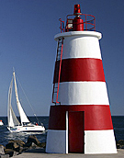
Portugal’s southernmost coastline, where the sea is warm and calm.
The Algarve has so much to offer. The sea is warm, the climate is wonderful and the holiday villages, hotels and luxury resorts are superb places to stay. And the small fishing villages - such as Santa Luzia, in Tavira - and the small port of Sagres are idyllic and peaceful.
The Algarve’s beaches meanwhile are among the best in the world. And there is so much variety to chose from - hidden beaches, family beaches, beaches where the sea is calm and beaches that are ideal for water sports. Whichever one you go for, there is always fun in abundance.
And don’t forget the golf! The Algarve has 30 golf courses and some are among the best in Europe. They will tempt amateurs and professionals alike.
In the Algarve people live their lives outdoors. So come and join them. Enjoy the atmosphere, the climate and the food on the terraces of one of our numerous cafés and restaurants.

FARO
Faro is the Algarve's capital and main transport hub. It's the gateway to the heavily-touristed coast and also a thriving commercial centre - but surprisingly pleasant for all that. The main sights of historical interest are within the compact old town centre.

Places to visit in Faro:

Igreja do Nossa Senhora do Carmo & Capela dos Ossos
The twin-towered, vanilla-and-butterscotch Church of Our Lady of Carmel was completed in 1719 under João V and paid for (and spectacularly gilded inside) with Brazilian gold. Behind the church is the Capela dos Ossos, built from the bones and skulls of more than a thousand monks as a pointed reminder of earthly impermanence, and the ultimate in recycling.
Hours: Oct-Apr: Mon-Fri 10:00am-1:00pm & 3:00pm-5:00pm, Sat 10:00am-1:00pm; May-Sep: Mon-Fri 10:00am-1:00pm & 3:00pm-6:00pm, Sat 10:00am-1:00pm

Milreu
The ruins of a grand Roman villa are set in beautiful countryside at Milreu and provide a rare opportunity to glimpse something of Roman life here. The lst-century AD ruins reveal the characteristic form of a peristyle villa, with a gallery of columns around a courtyard. Tantalising glimpses of the villa's former glory include the fish mosaics in the bathing chambers to the west of the villa's courtyard. Information sheets in various languages are available. Just north of Milreu is the enchantingly dishevelled Palácio do Visconde de Estói, well worth a visit for its overgrown sculpture filled gardens.
Hours: Apr-Sep: Tue-Sun 9:30am-12:30pm & 2:00pm-6:00pm; Oct-Mar: 9:30am-12:30pm & 2:00pm-5:00pm

Museu Etnográfico Regional do Algarve
Praça de Liberdade
Tel: 289 827 610 (info)
In the left entrance of the district assembly building is the Algarve Regional Ethnographic Museum. Elements of old peasant life are on display here - like a small fishing boat and a wooden water cart (used until the owner's death in 1974). There are also enigmatically labelled displays of ceramics, fabrics and Dioramas of typical interiors.
Hours: Mon-Fri 9:00am-12:30pm, 2:00pm-5:30pm

AZORES

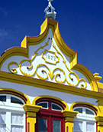
Think of a place to the west, where the nature and vegetation are pure and untouched, in the middle of the Atlantic Ocean.
Do you know where we’re talking about? The answer is the Azores, which offers you this and much more besides.
The Azores are nine different islands of adventure, nine delightful surprises. You can see dolphins and whales frolicking in the sea or volcanic landscapes covered in green. Then there are the stunning, lilac-coloured hydrangeas that provide hedges for the meadows; the blue and green lakes; the craters of extinct volcanoes and the steam rising from the land. The volcanic activity here means that you can even have your meal cooked under the ground!
Inland you can go mountain climbing and walking through the countryside. Or you can stick to the coast and go diving and swimming. On these amazing islands it feels as if time has stood still.
All of the islands have something to offer. Take Pico island, for instance. Classified as a world heritage site it boasts an amazing mountain, dramatic cliffs and vineyards formed from black basalt. And of course, you’ll want to discover the hot waters and the steam escaping from the vents of the volcanoes on the island of São Miguel.
In fact, it’s probable that you’ll be totally enchanted by the Azores.

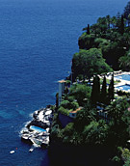
MADEIRA

Are you looking for a few days of relaxation and comfortable living? Then catch a plane to Madeira.
Madeira is a refined and sophisticated holiday destination, set in a spectacular landscape with a wonderful climate.
The top-quality hotels and excellent service mean that everybody feels comfortable and welcome. You’re sure to be tempted by the massages and modern therapies on offer. Why not treat yourself to a dip in one of Madeira’s spas?
Madeira is a tropical island. The Laurisilva Forest, in the Madeira Natural Park, is the largest evergreen forest in the world - a fact that has earned it classification as a world heritage site.
Elsewhere the exotic flowers and fruits compete with one another in their variety and colour. And then there’s the sea, always blue and visible from wherever you are.
Enjoy Madeira - a place of beauty, passion and romance.

Indian Restaurants in Portugal

Porto

Rota Da India- Avenida Boavista 2935, Porto

Lisbon

Arco do Castelo- R Chão Feira, 25, Lisbon
Bengal Tandoori- Rua da Alegria , 23, 1250 - 005 Next to Metro Avenida, Lisbon
Bengal Tandoori Ajuda- Calçada da Ajuda 93 - 1° 1300 - 007 Next to Palacio da Ajuda, Lisbon
Cantinho da Paz- R Poço Negros, 64, Lisbon
Delhi Palace- R da Padaria, n º 18/20, 1100-389, Lisbon
Estrela da Índia- R Freitas Reis, 15 B 2750 – CASCAIS, Lisbon
Everest Montanha- Calçada Garcia 15, Lisbon
Farahs Tandoori- Rua de Santana à Lapa, Lisbon
Gandhi Palace- Rua dos Douradores, 214-216 (Next to Rossio - metro) 1000 – LISBOA
Hare Krishna Vegetarian- Rua Dona Estefania 91, Lisbon
Haweli Tandoori- Tv Monte, 14 1100, Lisbon
Índia Palace- R Palma 208-D, Lisbon
Indian Corner- Av 25 Abril, Nº 81 Olhos d'Água – ALBUFEIRA, Lisbon
Kashmir- R Dr Gama Barros, 15 B 1700, Lisbon
Maharaja- R Cardal à S José, 21 1100,Lisbon
Mendi-on the side of the Meridien Hotel * Porto,Lisbon
Natraj-Av Igreja, 65 * Alvalade Lisbon
Natraj Classical-SÃO NICOLAU, R Sapateiros 171, Lisbon
Palheiro-Rebelva (Parede) 2775 - PAREDE, Lisbon
Sabores de Goa-Rua do Zaire, nº 17 B,Lisbon
Shalymar Garden-R nv Piedade 99,Lisbon
Taj Mahal-R Gaivotas, 17 A 1200,Lisbon
Tamarind-R Glória 43-r/c,Lisbon
Tentacoes de Goa-Rua S. Pedro Mártir, nº 23 r/c,Lisbon

Algarve

India- Escanchinas, 8135 Almancil, Algarve

